Leakage in Digital Markets: Evidence from Age Verification Laws
Griffin Applied Economics Incubator IO Grant
Matthew Brown, Assistant Instructional Professor
09/26/2025

Motivation
A classic problem with government regulation is that firms and consumers can evade consequences by transacting in illegal or less regulated markets. Substitution to unregulated products, or “leakage,” reduces the benefits of policies that are designed to reduce harmful consumption, like taxes and bans.

This proposal studies leakage in the context of internet pornography consumption and age verification laws. My research design exploits the quasi-random timing of policy rollout across U.S. states for causal identification. I will purchase internet activity data from Comscore to implement this design.

The project contributes to three strands of the literature. First, I contribute to the literature on leakage to unregulated products. The typical problem in this literature is that it is hard to observe unregulated transactions, but with my data, I can directly observe these transactions. Second, I contribute to the literature on substitution patterns online by providing novel estimates of substitutability both between adult websites and from adult websites to other kinds of websites. Finally, and most concretely relevant to policymakers, I would be the first paper to empirically analyze the consequences of age verification laws for online activity. Beyond the pornography context, age verification has been proposed for other kinds of online activity, like social media. There has been fierce public debate around age verification, with critics claiming that the laws do not accomplish their stated goals because of leakage. Ultimately, the extent of leakage is an empirical question, which this study will answer.

Research Design
My research design exploits the staggered rollout of age verification laws across U.S. states with a difference-in-differences strategy. 15 U.S. states passed age verification laws that went into effect between 2023 and 2024, which provides the necessary policy variation. Because most laws were passed by right-leaning states, I rely on quasi-random timing for identification.

Pilot tests of this design using data from Google Trends show that the laws do affect behavior. Figure 1 illustrates the impacts of Louisiana’s age verification laws on google searches for the two largest pornography websites, only one of which complied with the law (by requiring photo ID verification). Searches for the compliant website fell by more than half. However, searches for the non-compliant website increased, which we take as preliminary evidence of leakage.
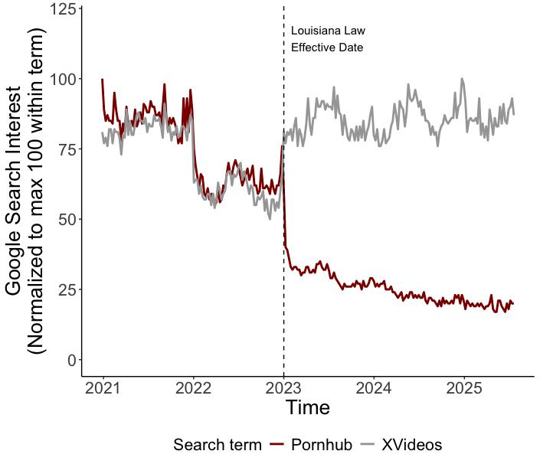
Figure 1: The impact of Louisiana’s age verification law on search traffic.
Notes: The figure illustrates google search interest for the two most popular adult websites in the United States, one of which complied with the regulation by requiring age verification (Pornhub) and the other of which did not comply with the regulation.

The google trends data has several key weaknesses – for example, I can only access data on coarse search terms, magnitudes are impossible to interpret, and it impossible to learn about which people substitute away. I will address these issues by purchasing internet activity data from Comscore. Specifically, the Comscore dataset is a repeated cross section with about 150,000 U.S. internet user panelists in any given month. The Comscore dataset contains rich information on everything the users do online. For this study, the key information is about which websites people visit and when. I will purchase data from 2022-2024, which is the period where there is variation in the age verification laws.

Broader Benefits to UChicago
This grant would provide substantial spillover benefits to the broader UChicago research community. Comscore is the world’s leading provider of observational data on how individuals use the web for academic research. If I purchase this data, Comscore would execute a contract with the University, which would allow other researchers at UChicago to use the data to study internet activity. The alternative applications of the dataset are too numerous to name.

Budget
I am requesting the full $25,000 in funds. All of it would be used for data purchase. The full cost of Comscore data for the 2022-2024 period is around $65,000, so I plan to supplement this grant with funds from private foundations or from collaborators’ research budgets. If I am only able to secure funds from this grant, that would still be sufficient to buy a subsample of the Comscore data. The purchase would be complete by March of 2026, and possibly sooner – the only reason for the delay would be to determine the scope of the purchase. I anticipate that I would be able to present preliminary results in the Spring 2026 workshop.

For example, a spokesperson for a large pornography website highlighted leakage in the context of the UK’s age verification law: “As we've seen in many jurisdictions around the world, there is often a drop in traffic for compliant sites and an increase in traffic for non-compliant sites.” (Link to BBC)
The fact that some websites do not comply with regulation illustrates one of the reasons that this is an interesting setting to study leakage – I am able to study firm responses to the law as a strategic decision.

